Sentiment🡪All, Priority🡪All, Issue Type🡪All

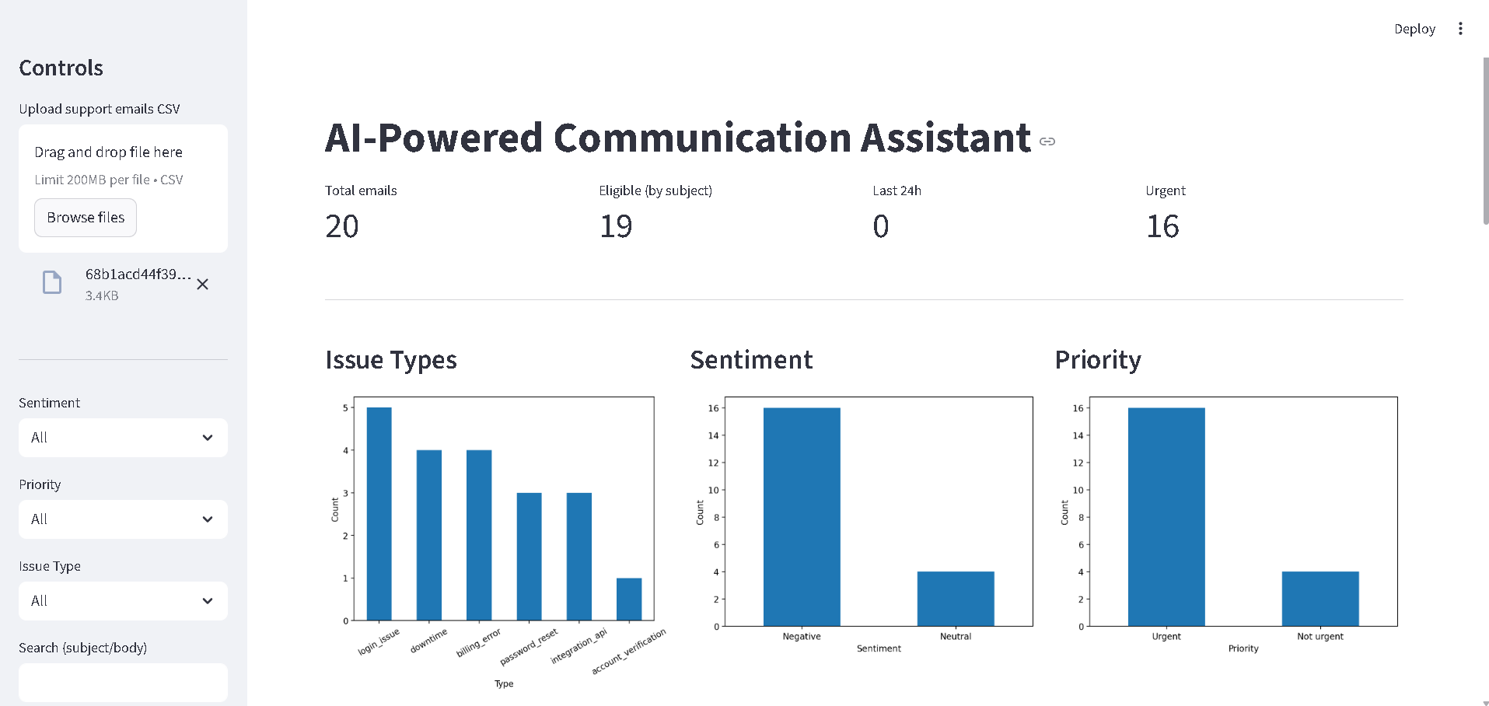

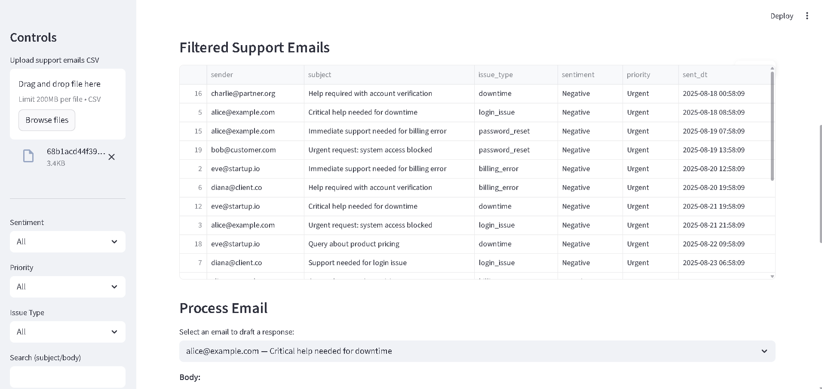

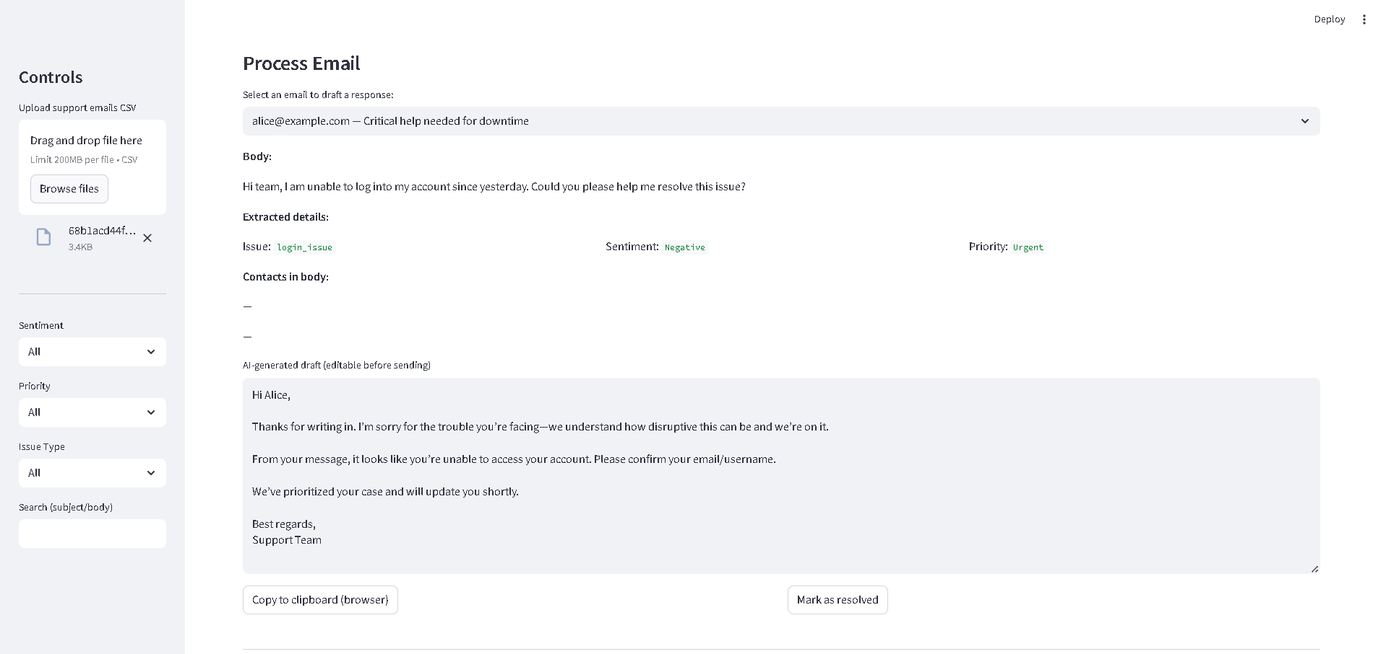

Sentiment🡪Negative, Priority🡪All, Issue Type🡪All

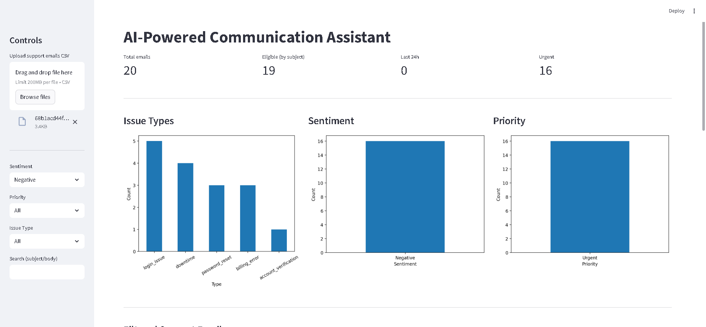

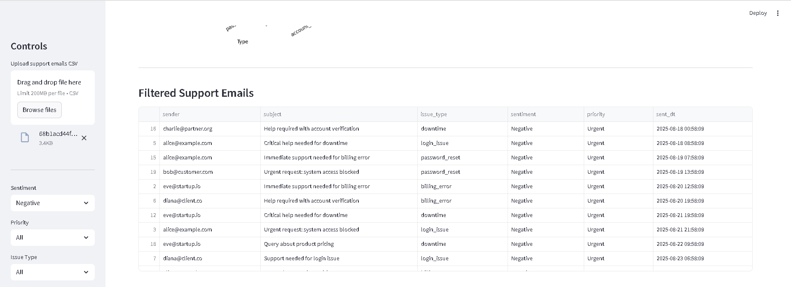

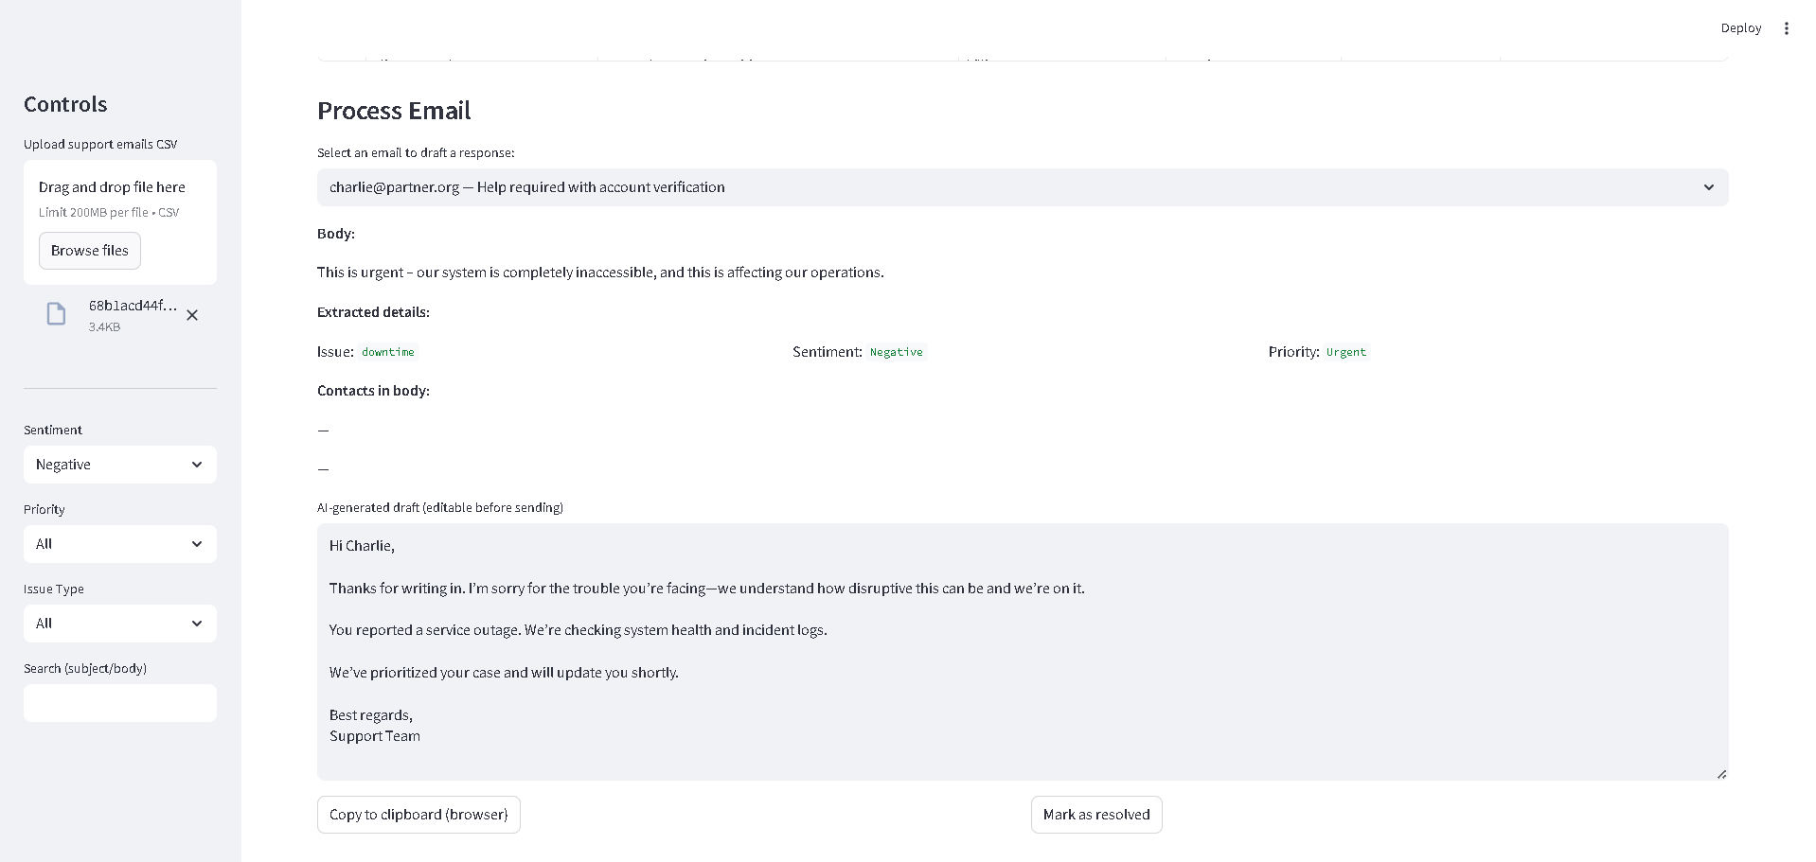

Sentiment🡪Negative, Priority🡪Not Urgent, Issue Type🡪All

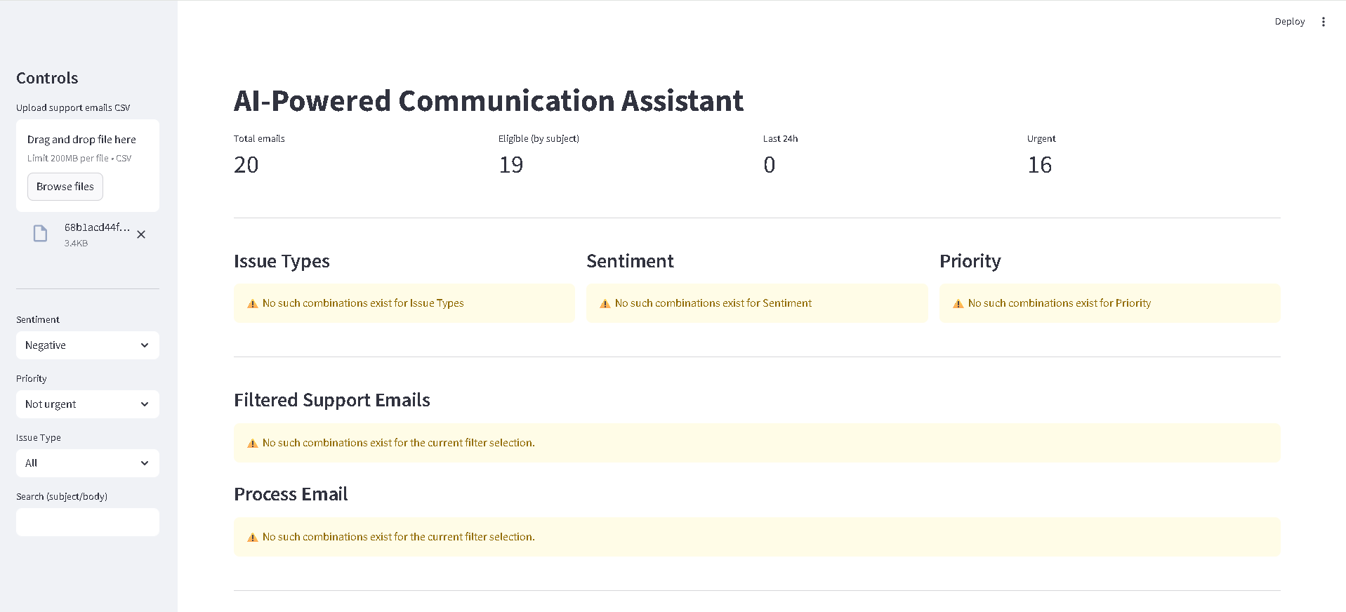

Sentiment🡪Negative, Priority🡪Urgent, Issue Type🡪All

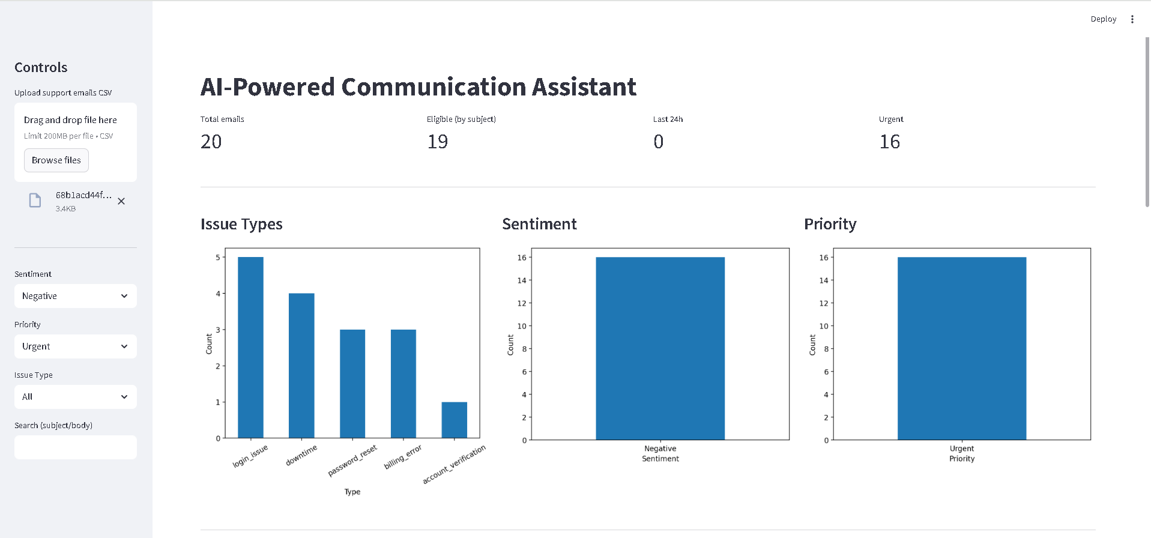

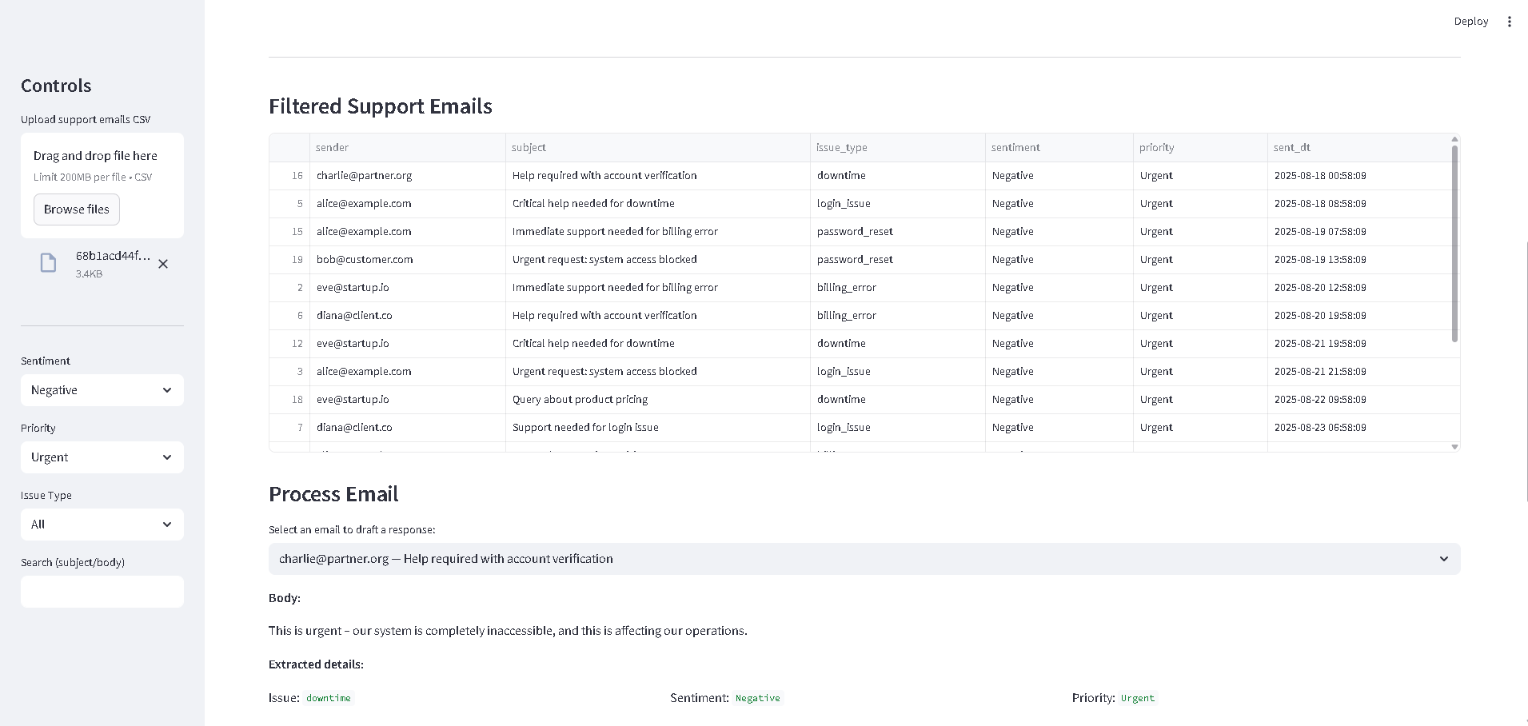

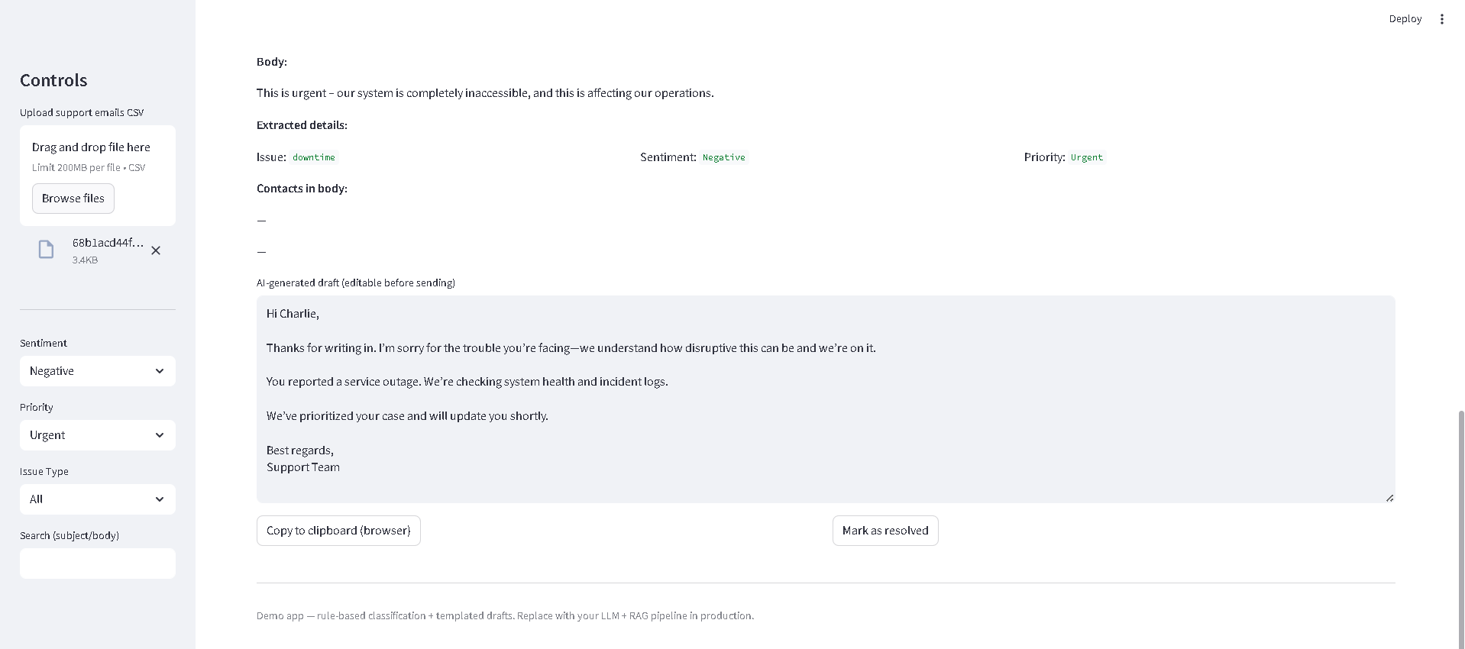

Sentiment🡪Negative, Priority🡪Urgent, Issue Type🡪Account verification

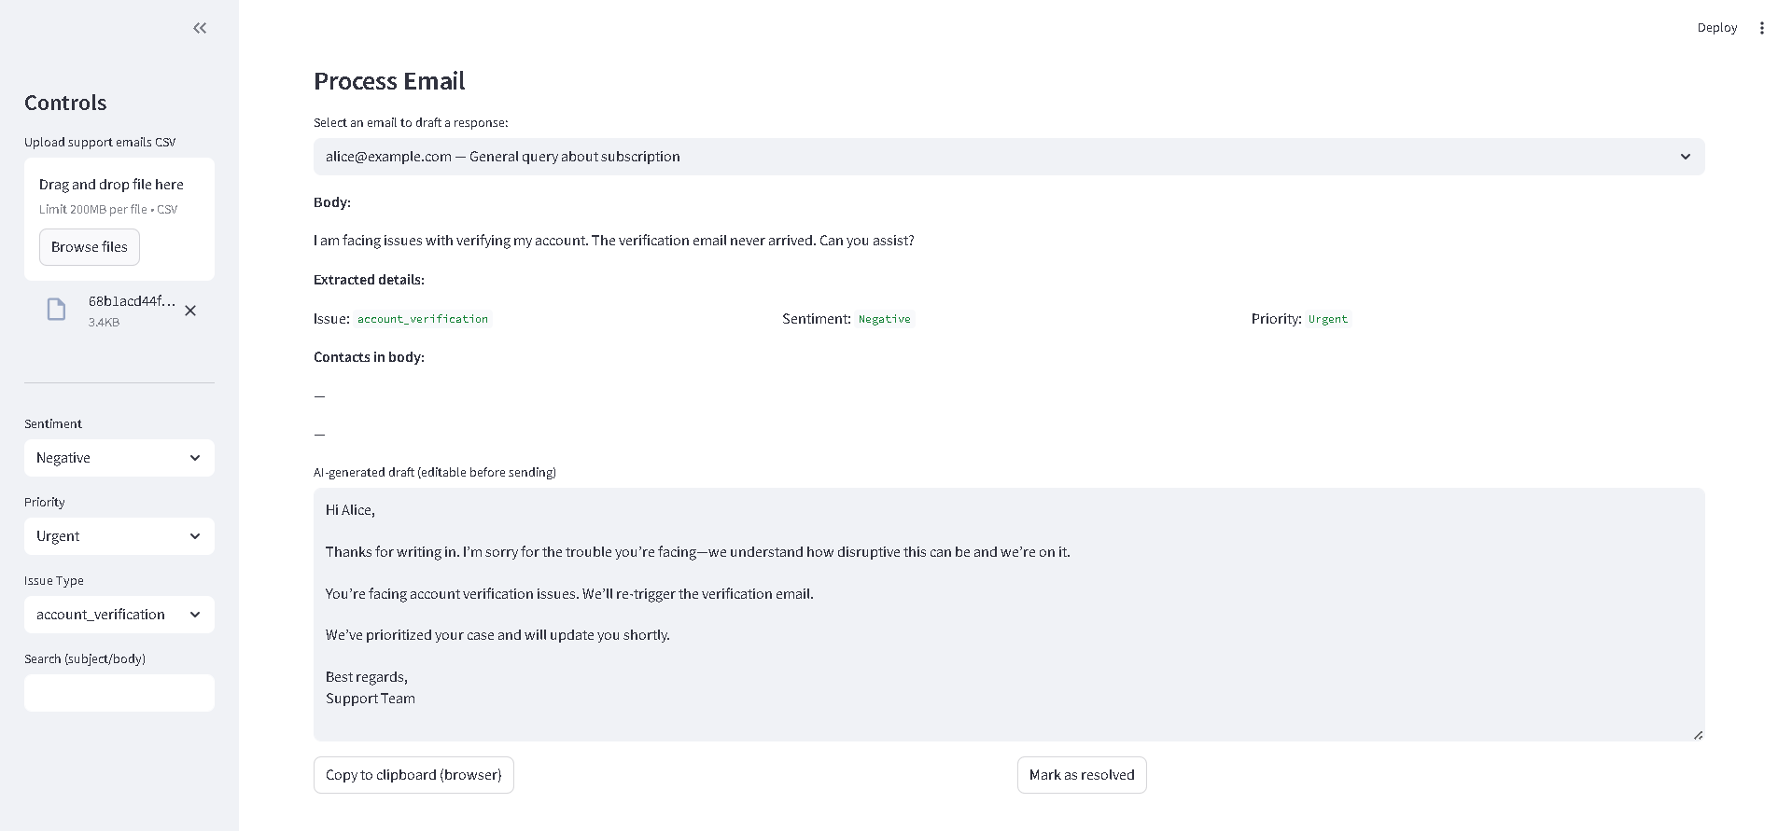

Sentiment🡪Negative, Priority🡪Urgent, Issue Type🡪Billing error

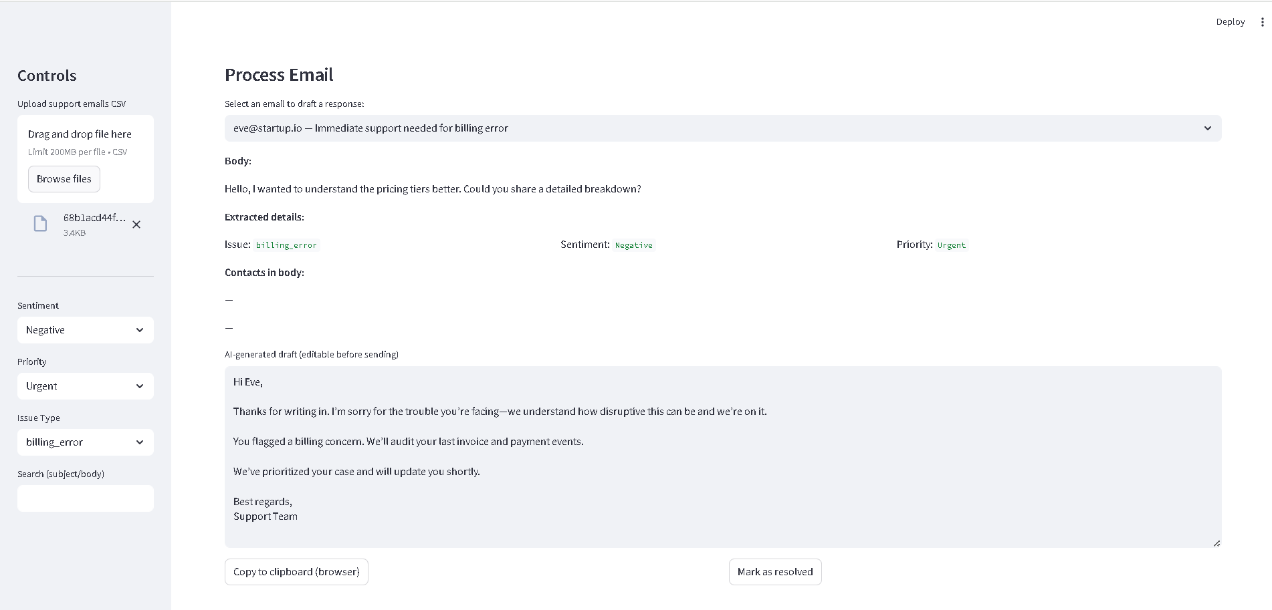

Sentiment🡪Negative, Priority🡪Urgent, Issue Type🡪Down time

